* **PL &SQL Array concept**

DECLARE

type namesarray IS VARRAY(5) OF VARCHAR2(10);

type grades IS VARRAY(5) OF INTEGER;

names namesarray;

marks grades;

total integer;

BEGIN

names := namesarray('Kavita', 'Pritam', 'Ayan', 'Rishav', 'Aziz');

marks:= grades(98, 97, 78, 87, 92);

total := names.count;

dbms_output.put_line('Total '|| total || ' Students');

FOR i in 1 .. total LOOP

dbms_output.put_line('Student: ' || names(i) || '

Marks: ' || marks(i));

END LOOP;

END;

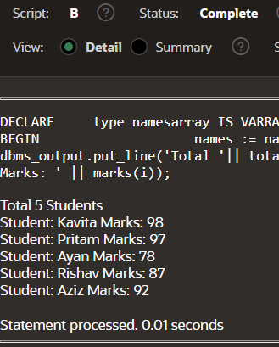

* **Count the even and odd**

DECLARE

v_number NUMBER := 23146579;

v_odd_count NUMBER := 0;

v_even_count NUMBER := 0;

v_digit NUMBER;

BEGIN

WHILE v_number > 0 LOOP

v_digit := MOD(v_number, 10);

IF MOD(v_digit, 2) = 0 THEN

v_even_count := v_even_count + 1;

ELSE

v_odd_count := v_odd_count + 1;

END IF;

v_number := TRUNC(v_number / 10);

END LOOP;

DBMS_OUTPUT.PUT_LINE('Count of odd digits: ' || v_odd_count);

DBMS_OUTPUT.PUT_LINE('Count of even digits: ' || v_even_count);

END;

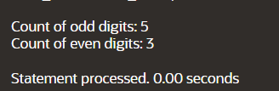

* **Find Minimum**

DECLARE

a number;

b number;

c number;

PROCEDURE findMin(x IN number, y IN number, z OUT number) IS

BEGIN

IF x < y THEN

z:= x;

ELSE

z:= y;

END IF;

END;

BEGIN

a:= 23;

b:= 45;

findMin(a, b, c);

dbms_output.put_line(' Minimum of (23, 45) : ' || c);

END;



* **MAXIMUM NUMBER**

DECLARE

a number;

b number;

c number;

FUNCTION findMax(x IN number, y IN number)

RETURN number

IS

z number;

BEGIN

IF x > y THEN

z:= x;

ELSE

Z:= y;

END IF;

RETURN z;

END;

BEGIN

a:= 23;

b:= 45;

c := findMax(a, b);

dbms_output.put_line(' Maximum of (23,45): ' || c);

END;



**FIBONACCI SERIES**

DECLARE

i NUMBER;

FUNCTION fibonacci(n NUMBER) RETURN NUMBER

IS

BEGIN

IF n <= 0 THEN

RETURN 0;

ELSIF n = 1 THEN

RETURN 1;

ELSE

RETURN fibonacci(n-1) + fibonacci(n-2);

END IF;

END fibonacci;

BEGIN

FOR i IN 0..10 LOOP

DBMS_OUTPUT.PUT_LINE('Fibonacci(' || i || ') = ' || fibonacci(i));

END LOOP;

END;

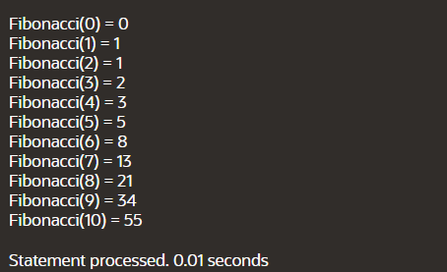

* **FACTORIAL USING RECURTION**

DECLARE

num number;

factorial number;

FUNCTION fact(x number)

RETURN number

IS

f number;

BEGIN

IF x=0 THEN

f := 1;

ELSE

f := x * fact(x-1);

END IF;

RETURN f;

END;

BEGIN

num:= 6;

factorial := fact(num);

dbms_output.put_line(' Factorial '|| num || ' is ' || factorial);

END;

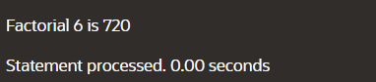

* **FIBONACCI**

DECLARE

n1 NUMBER := 0;

n2 NUMBER := 1;

n3 NUMBER;

counter NUMBER := 2;

terms NUMBER := 10;

BEGIN

DBMS_OUTPUT.PUT_LINE(n1);

DBMS_OUTPUT.PUT_LINE(n2);

WHILE counter < terms LOOP

n3 := n1 + n2;

DBMS_OUTPUT.PUT_LINE(n3);

n1 := n2; -- Update n1 to the next number

n2 := n3; -- Update n2 to the next number

counter := counter + 1;

END LOOP;

END;

/

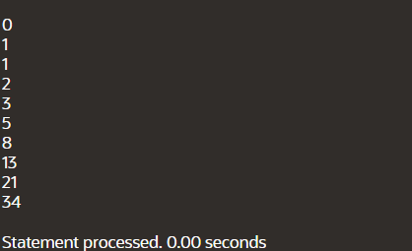]

**IMPLICITY**

DECLARE

total_rows number(2);

BEGIN

UPDATE COP3

SET AGE = AGE + 5;

IF sql%notfound THEN

dbms_output.put_line('no customers selected');

ELSIF sql%found THEN

total_rows := sql%rowcount;

dbms_output.put_line( total_rows || ' customers selected ');

END IF;

END;

BEFORE TABLE:

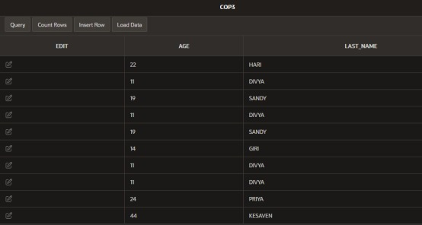

AFTER TABLE:

